Possible Issues
1.After launching the application, the user transitions from the welcome page to the onboarding pages. On the last onboarding page, tapping "Continue" directly triggers the subscription pop-up, which does not display the subscription price or subscription details.
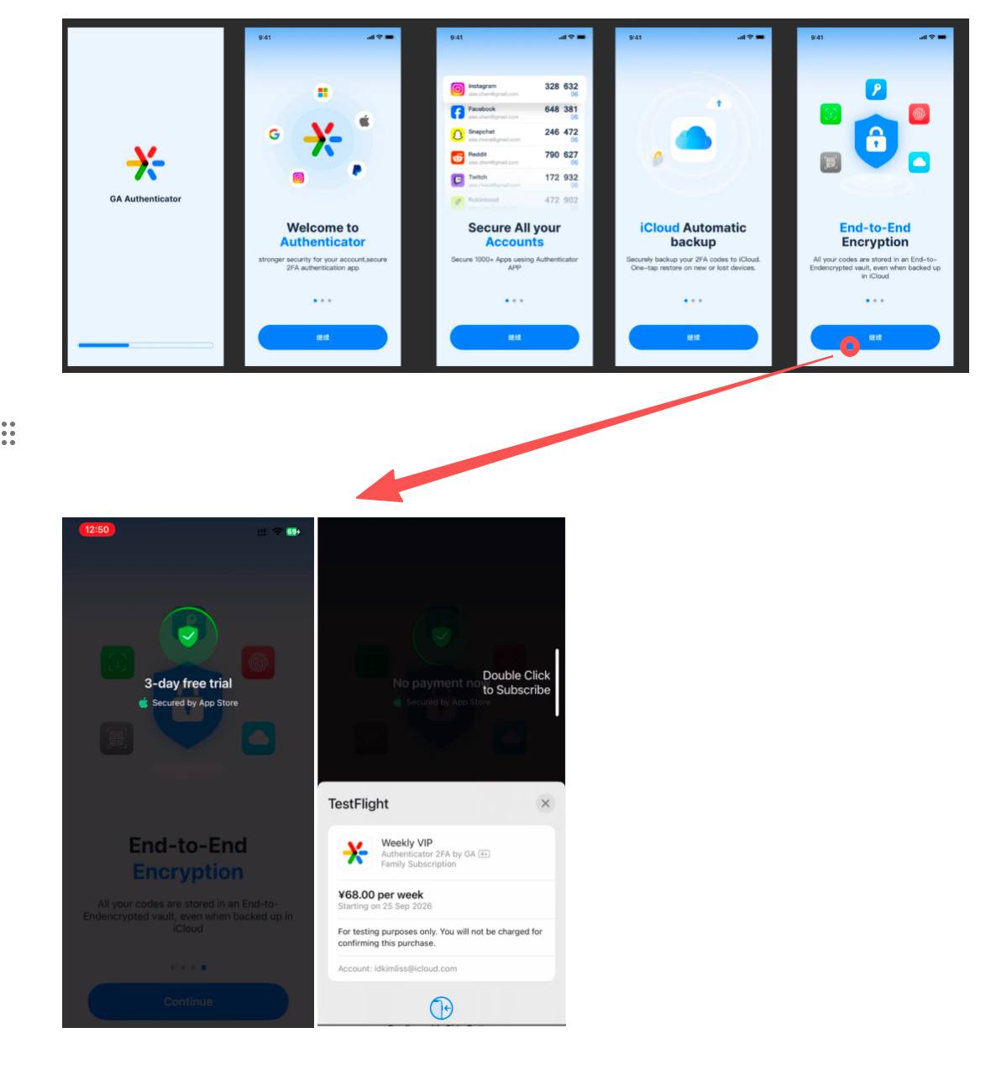
2. After the user dismisses the subscription pop-up, the app automatically navigates to a trial transition page, where another subscription page pops up again. The try button on this page displays a price of 0.00, and the close button does not appear immediately (it appears only after 10 seconds). Users cannot dismiss the page before the close button becomes visible.
